|  |
| --- |
| Obstacle Avoiding Vehicle  (CS227 Project Report) |
|  |
| DEVESH KUMAR PANDEY  2101MC16  MATHEMATICS AND COMPUTING |

INTRODUCTION

Now day’s Electric Vehicles are in high demand due to their high level of performance and reliability and which is a great help for human beings. The obstacle avoidance robotics is used for detecting obstacles and avoiding the collision. This is an autonomation of vehicle. The design of the obstacle avoidance robot requires the integration of many sensors according to their task.

Obstacle detection is the primary requirement of this automatic vehicle. The vehicle gets the information from the surrounding area through mounted sensors on the vehicle. Some sensing devices used for obstacle detection like bump sensors, infrared sensors, ultrasonic sensors, etc. The ultrasonic sensor is most suitable for obstacle detection and it is of low cost and has a high ranging capability.

HARDWARE REQUIREMENTS

Hardware:

• Arduino UNO R3

• Ultrasonic sensor HC-SR04

• DC Motors (2)

• Motor Driver Shield (L293D)

• Battery (9V)

• Jumper Wires

• Chassis

• Wheels

BLOCK DIAGRAM

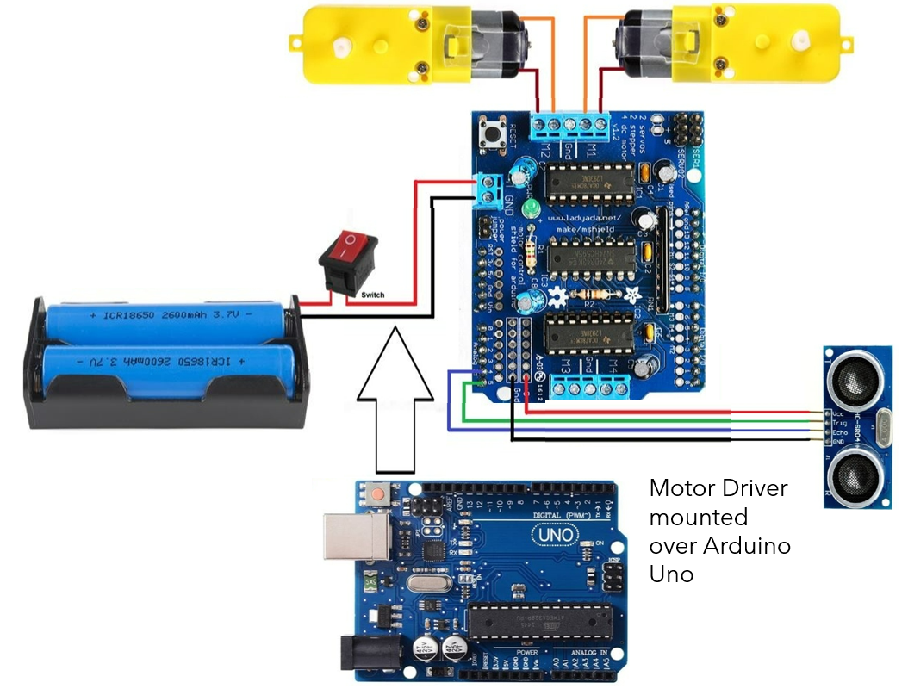

The basic block diagram of the obstacle avoiding car is shown in above figure. Mainly this block diagram consists other following essential blocks.

1. Arduino uno

2. Ultrasonic sensor

3. Motor driver(L293D)

1) Arduino uno - Arduino Uno is an ATmega 328p Microcontroller based prototyping board. It is an open source electronic prototyping platform that can be used with various sensors and actuators. It is used for controlling all the operation and assign task to each device.

2) Ultrasonic sensor - It is an Ultrasonic Range Finder Sensor. It is a non-contact based distance measurement system and can measure distance of 2cm to 4m. Ultrasonic sensor is mainly use to detect the obstacle.

3) Motor driver - It is a motor driver which can provide bi-directional drive current for two motors.

WORKING

The obstacle avoidance electric vehicle uses ultrasonic sensors for its movements. Arduino is used to achieve the desired operation. The motors are connected through motor driver IC to Arduino. The ultrasonic sensor is attached in front of the robot.

Whenever the robot is going on the desired path the ultrasonic sensor transmits the ultrasonic waves continuously from its sensor head. Whenever an obstacle comes ahead of it the ultrasonic waves are reflected back from an object and that information is passed to the Arduino UNO. The Arduino controls the motors left, right, back, front, based on ultrasonic signals. In order to control the speed of each motor pulse width modulation is used (PWM).

When ultrasonic sensor detect the obstacle which is in the path it will send the signal toward the Arduino uno and according to that it will it will rotate the motor M1 in forward direction and rotate the motor M2 in reverse direction such way that the car get moving in left direction.

ARDUINO UNO

The Arduino Uno is an open-source microcontroller board based on the Microchip [ATmega328P](https://en.wikipedia.org/wiki/ATmega328P) microcontroller. The board is equipped with sets of digital and input/output (I/O) pins that may be interfaced to various expansion boards (shields) and other circuits. The board has 14 digital I/O pins (six capable of [PWM](https://en.wikipedia.org/wiki/Pulse-width_modulation) output), 6 analog I/O pins, and is programmable with Arduino IDE, via a USB cable. It can be powered by the USB cable or by an external 9-volt battery, though it accepts voltages between 7 and 20 volts.

L293D Motor Driver Shield

It is capable of controlling various motors like DC motors, stepper motors, and servos. The brains of the shield are two L293D motor drivers and a 74HC595 shift register. The L293D is a dual-channel H-Bridge motor driver that can control two DC motors or a single stepper motor. Because the shield includes two such motor drivers, it can control up to four DC motors or two stepper motors.

The 74HC595 shift register, on the other hand, extends the Arduino’s four digital pins to the eight direction control pins of two L293D chips.

DC MOTORS

The obstacle detection and avoiding robot uses two 200rpm and 12V DC geared motors. The motor used has a 6mm shaft diameter with internal holes. The internal holes are for easy mounting of the wheels by using screws. It is an easy to use low cost motor for robotics application.

An Electric DC motor is a machine which converts electric energy into mechanical energy. The working of DC motor is based on the principle that when a current carrying conductor is placed in a magnetic field, it experiences a mechanical force.

ULTRASONIC SENSOR

• An Ultrasonic sensor is a device that can measure the distance to an object by using sound waves. It measures distance by sending out a sound wave at a specific frequency and listening for that sound wave to bounce back. By recording the elapsed time between the sound wave being generated and the sound wave bouncing back, it is possible to calculate the distance between the sonar sensor and the object.

• It emits an ultrasound at 40,000 Hz which travels through the air and if there is an object or obstacle on its path It will bounce back to the module. Considering the travel time and the speed of the sound you can calculate the distance.

• The HC-SR04 Ultrasonic Module has 4 pins, Ground, VCC, Trig and Echo. The Ground and the VCC pins of the module needs to be connected to the Ground and the 5 volts pins on the Arduino Board respectively and the trig and echo pins to any Digital I/O pin on the Arduino Board.

• In order to generate the ultrasound you need to set the Trig on a High State for 10 µs. That will send out an 8 cycle sonic burst which will travel at the speed sound and it will be received in the Echo pin. The Echo pin will output the time in microseconds the sound wave traveled.

CONCLUSION

When the code is uploaded to Arduino Uno, Vehicle turns left if an obstacle comes in the range of 10 cm from it. It can be used as automation of vehicle. We can improve it by checking for other directions with no obstacles using more ultrasonic sensors or servo motor.